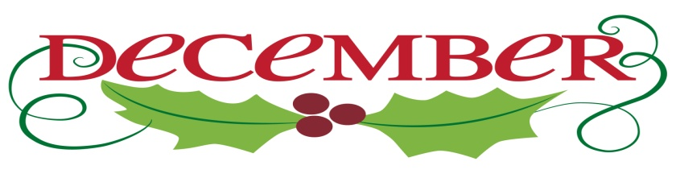

1. Yvonne Fisher

3 Hunter Lipscomb

6 Rachel Cole

Andrea Dodgion

Dawn Henson

Jennifer Jessen

7 William Tedder

9 Mark Collins

10 Nathan Gunter

Jeffrey Johnson

11 Rayford Sowell

12 Patricia Copes

13 Heather Stewart

16 Glenn Collins

Christopher Gunter

17 Chris Glass

Megan Gunter

Susan Putnam

18 Linda Stables

28 Glynis Ashby

20 Dana Ayers

Belinda Harris

Travis Maddox

21 Rev. Becky Cloud

Rebecca Steward

22 Neta Pearson

Jane White

23 Linda Jessen

Loretta Mayhew

Michael Redwood

Shaman Sunderland

26 Jane Muller

29 Cookie Fish

30 Christopher Woolley

